

**ECEN 5053-003 Homework Assignment**

Course Name: Embedding Sensors and Actuators

Corresponding Module: C2M5

Week Number: 8

Module Name: Stepper Motors

Note: Correct answer is in Blue Font

Homework is worth 100 points.

Part 1: Each question is worth 10 points.

1. What happens to a stepper motor if the coil windings are energized and an external torque tries to rotate the motor?

Answer: If the coil windings are energized then the motor is at standstill, with heavy magnetic coupling between stator and rotor. Therefore, **it will try to remain in the same condition, whenever the external torque is applied – it will resist that torque, producing force in reverse way, by increasing current consumption** [**[1]**](https://motion.schneider-electric.com/technology-blog/stepper-motor-basics-stable-shaft-positions/) .

1. In the slide deck C2M4V4 we discussed a simplified demonstration of how two stator phases are energized and de-energized in a set sequence to make the motor rotate 90° clockwise in four steps during one full rotation clockwise. See this slide below for an example of how this was done.

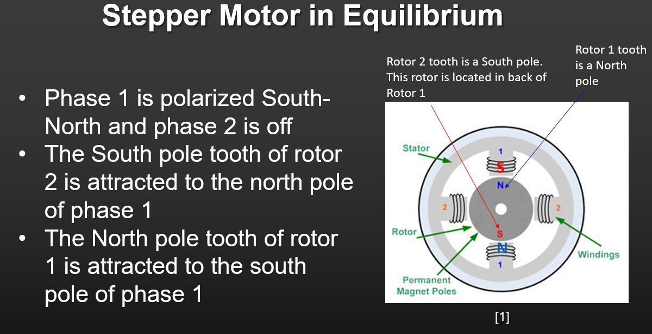

What sequence of energizing and de-energizing the stator phases would you use to make the motor rotate 90° ***counterclockwise*** in four steps during one full rotation counterclockwise? Start your sequence with the image in the slide above. Use diagrams to illustrate your sequence. Feel free to mark up our class slides, as a method of creating illustrations.

Answer: **Phase-2 Off & Phase-1 S-N on, Phase-1 Off & Phase-2 S-N, Phase-2 Off & Phase-1 N-S, Phase-1 Off & Phase-2 N-S.**

Equilibrium position 1 – Phase 1 – South to North Energized, Phase 2 Off

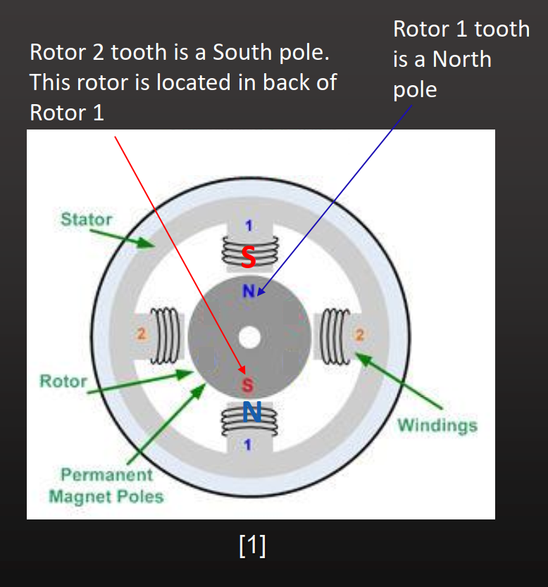

Transition – De-energizing Phase 1, Phase 2 – South to North Energized

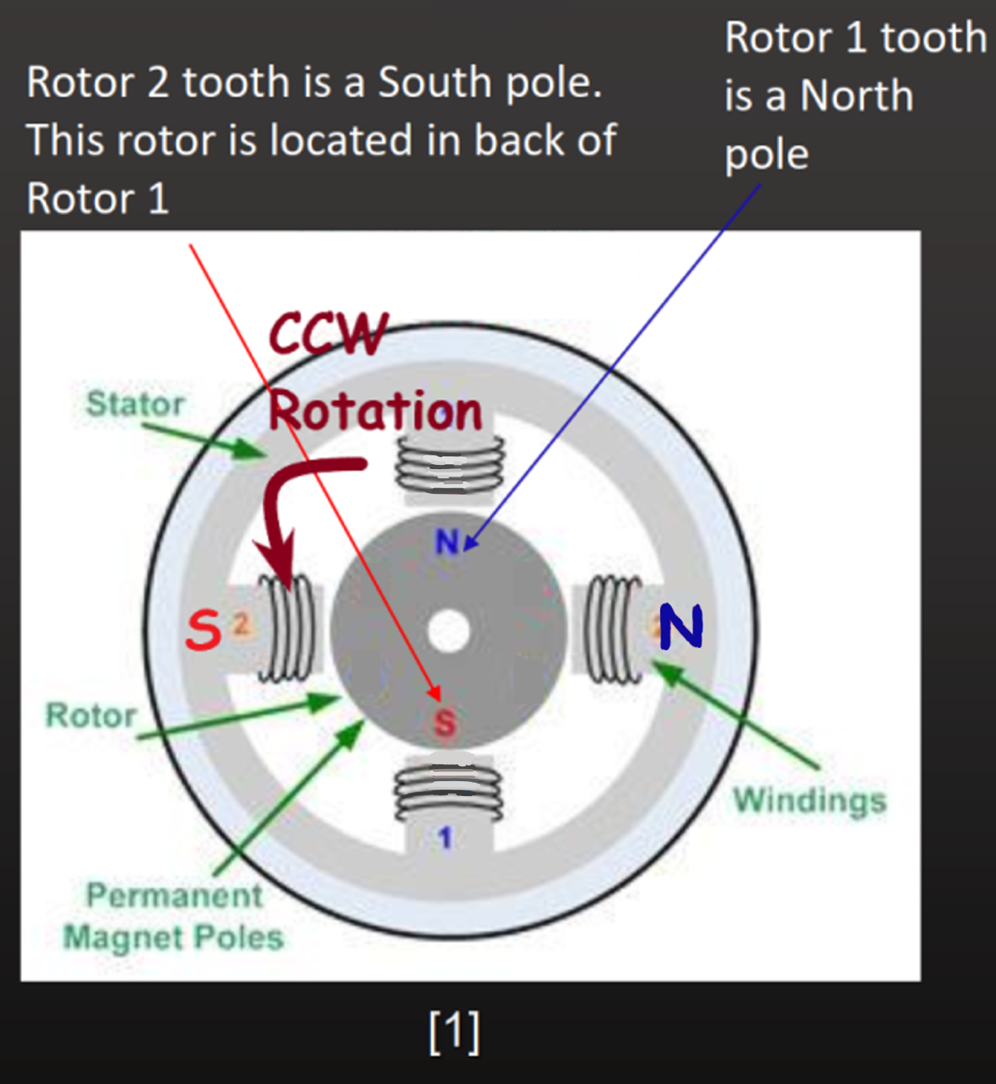

Equilibrium position 2 – Phase 2 – South to North Energized, Phase 1 Off

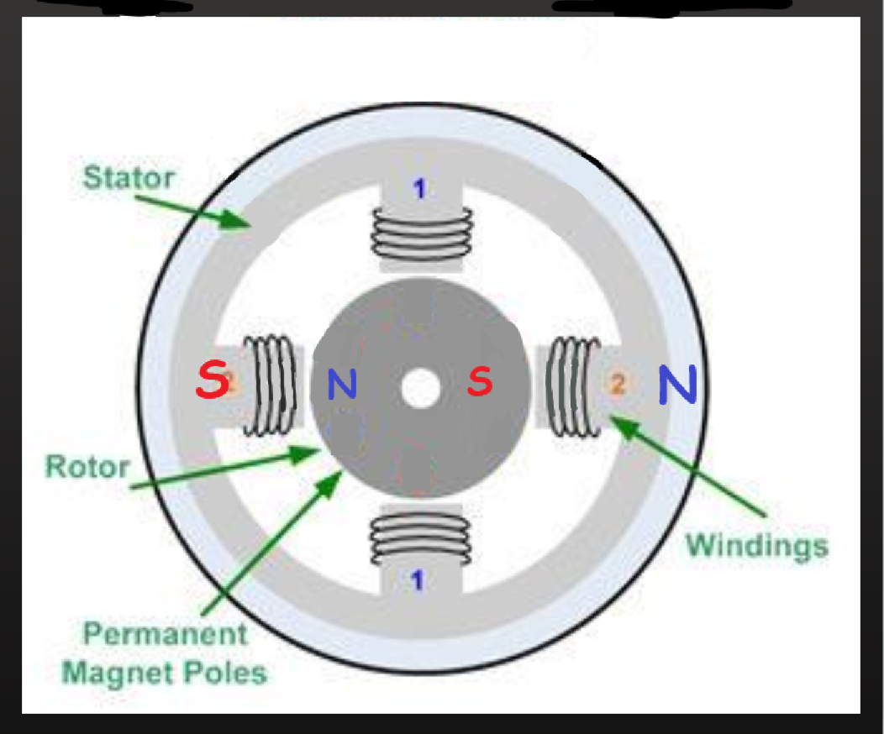

Transition – De-energizing Phase 2, Phase 1 – North to South Energized

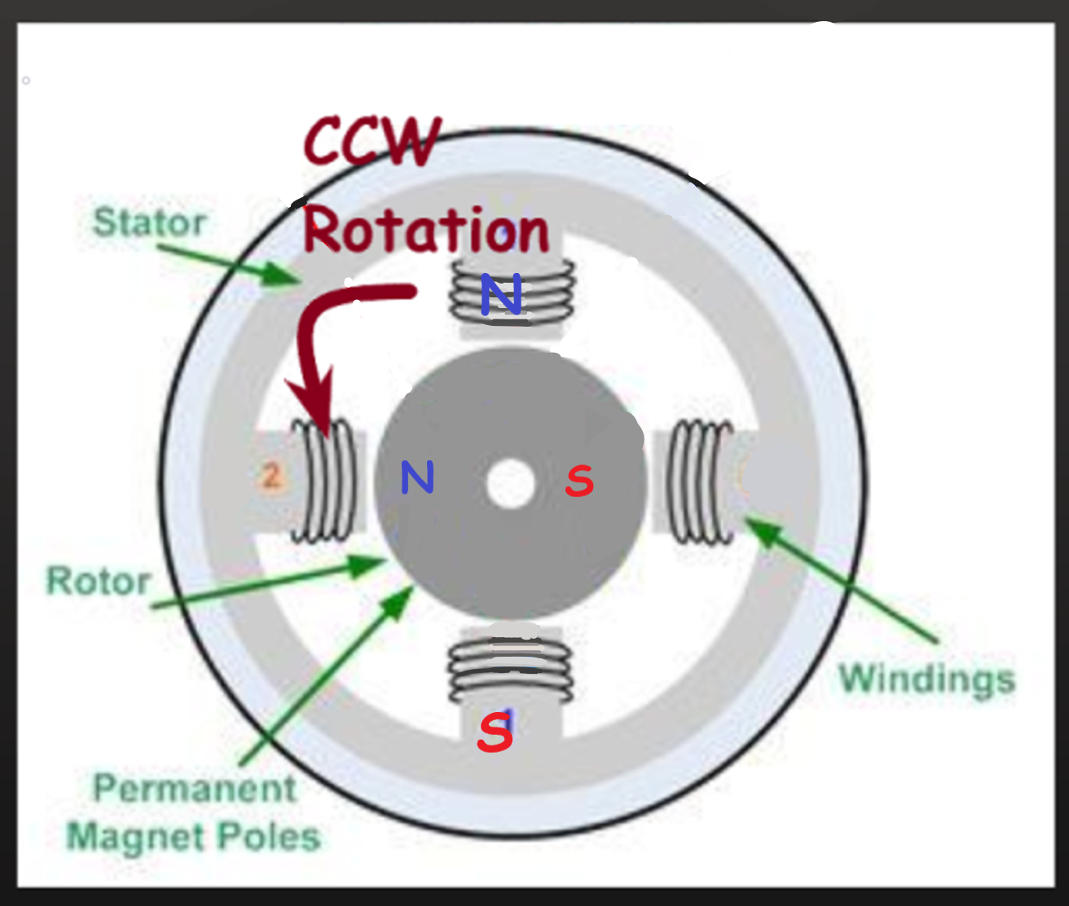

Equilibrium position 3 – Phase 1 – North to South Energized, Phase 2 Off

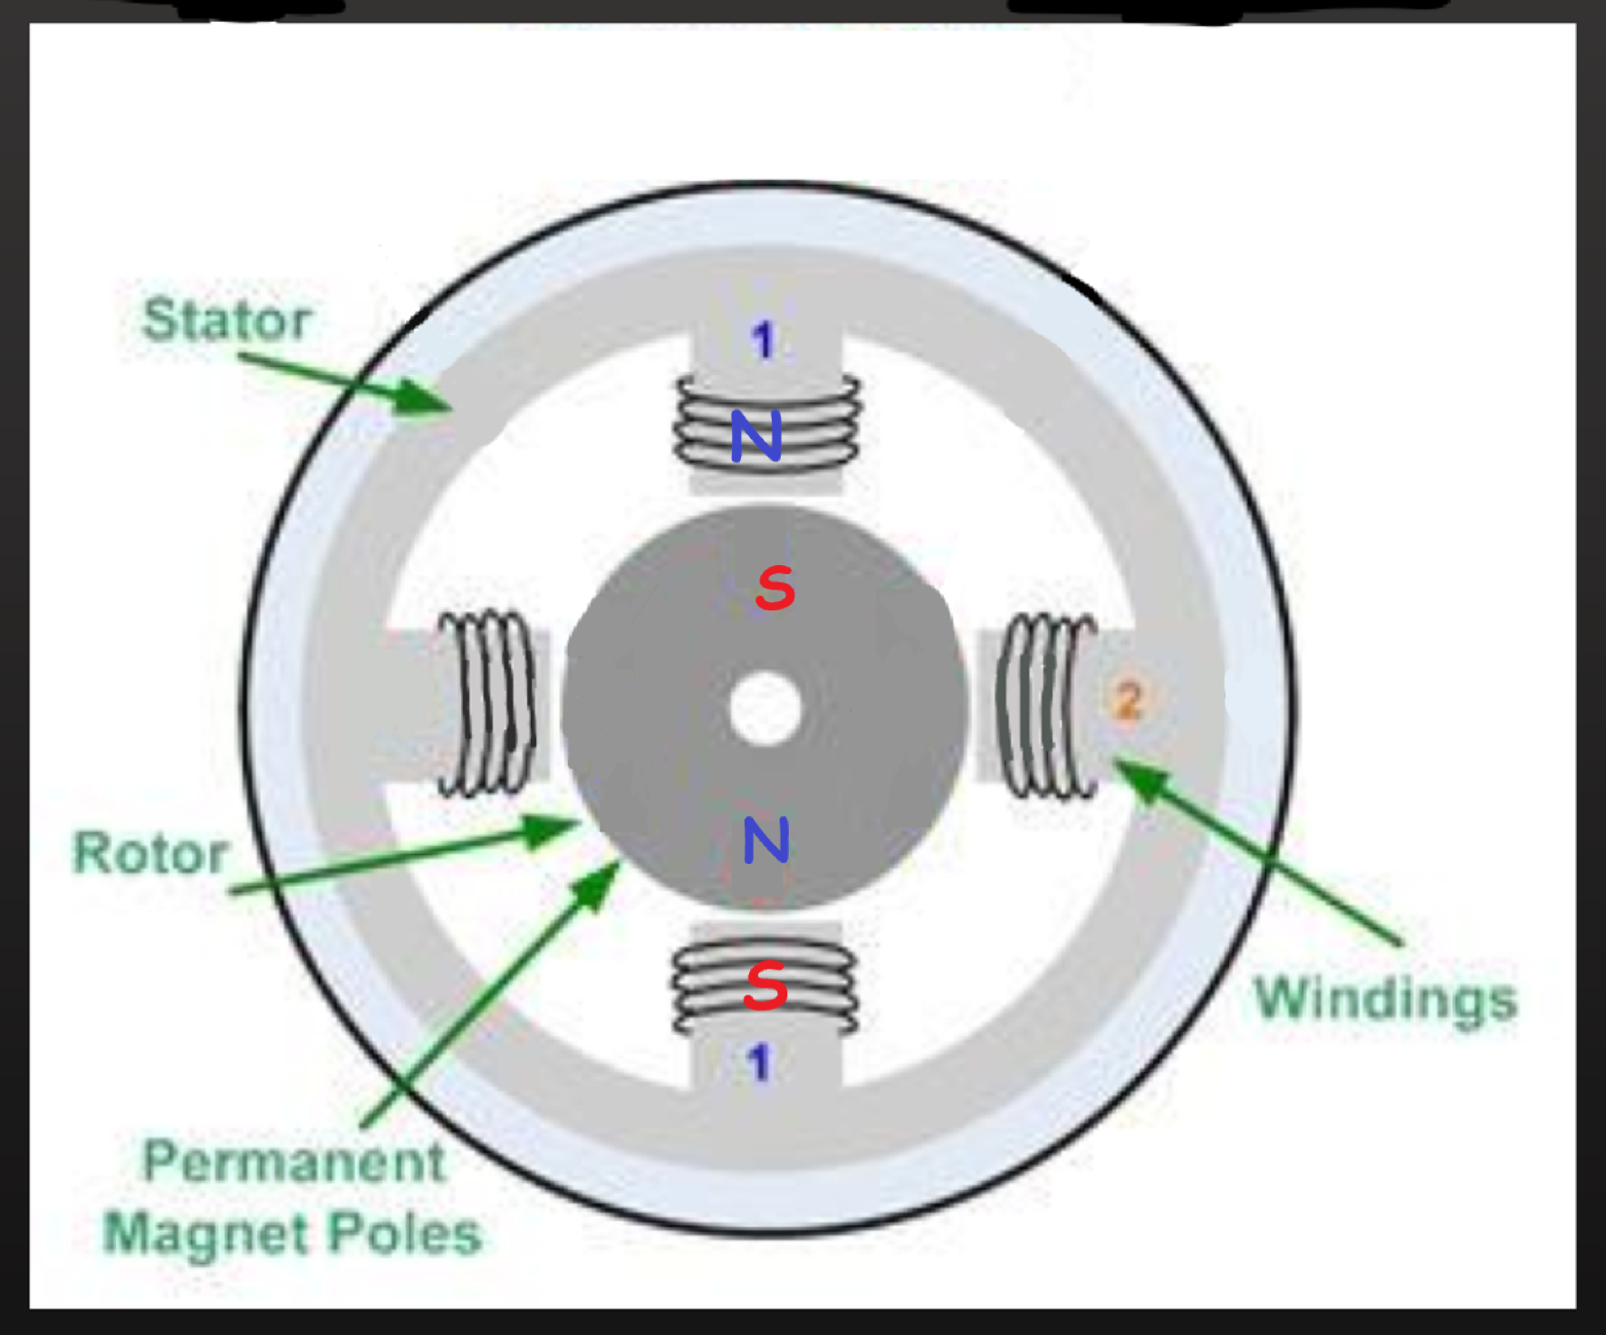

Transition – De-energizing Phase 1, Phase 2 – North to South Energized

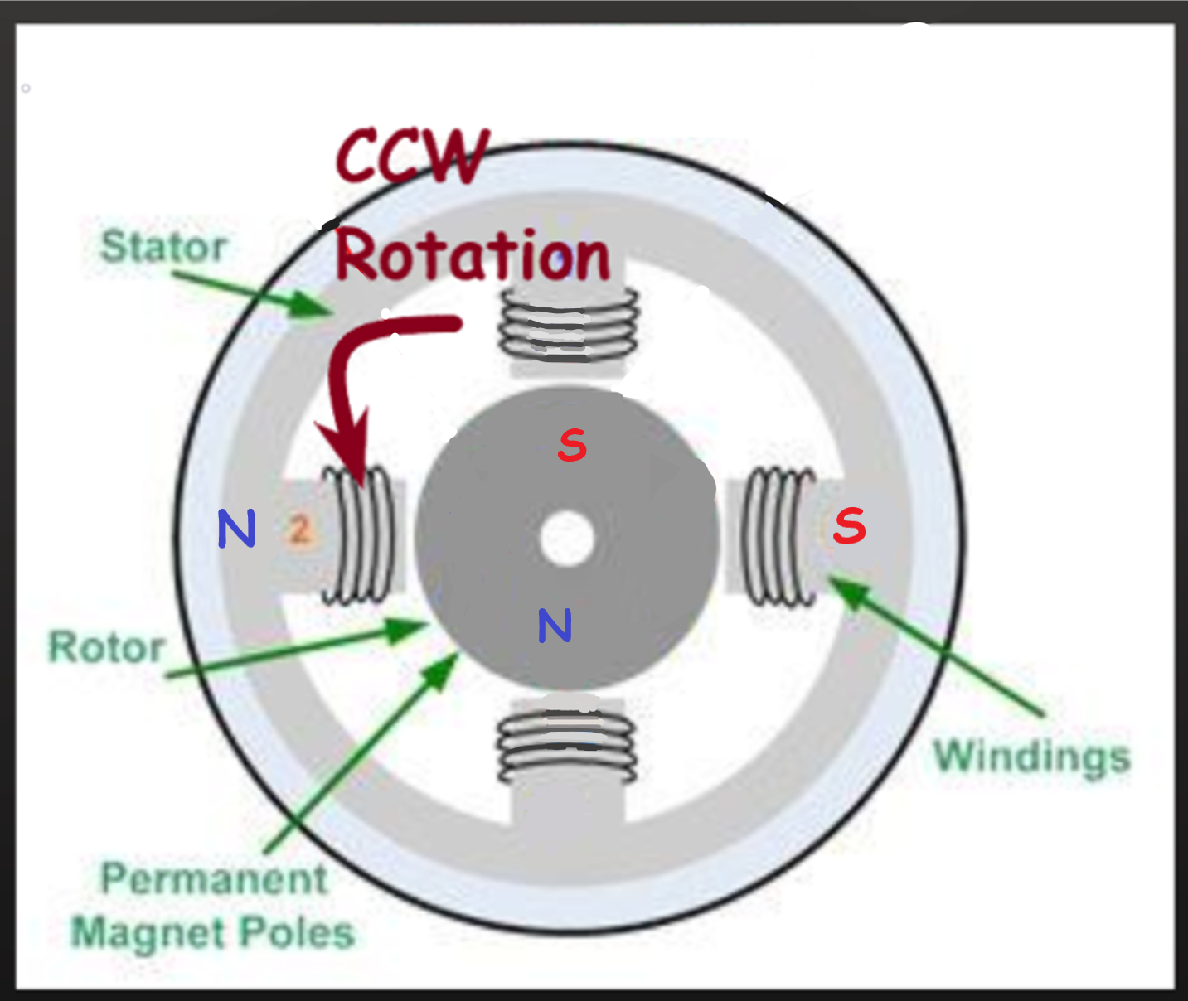

Equilibrium position 4 – Phase 2 – North to South Energized, Phase 1 Off

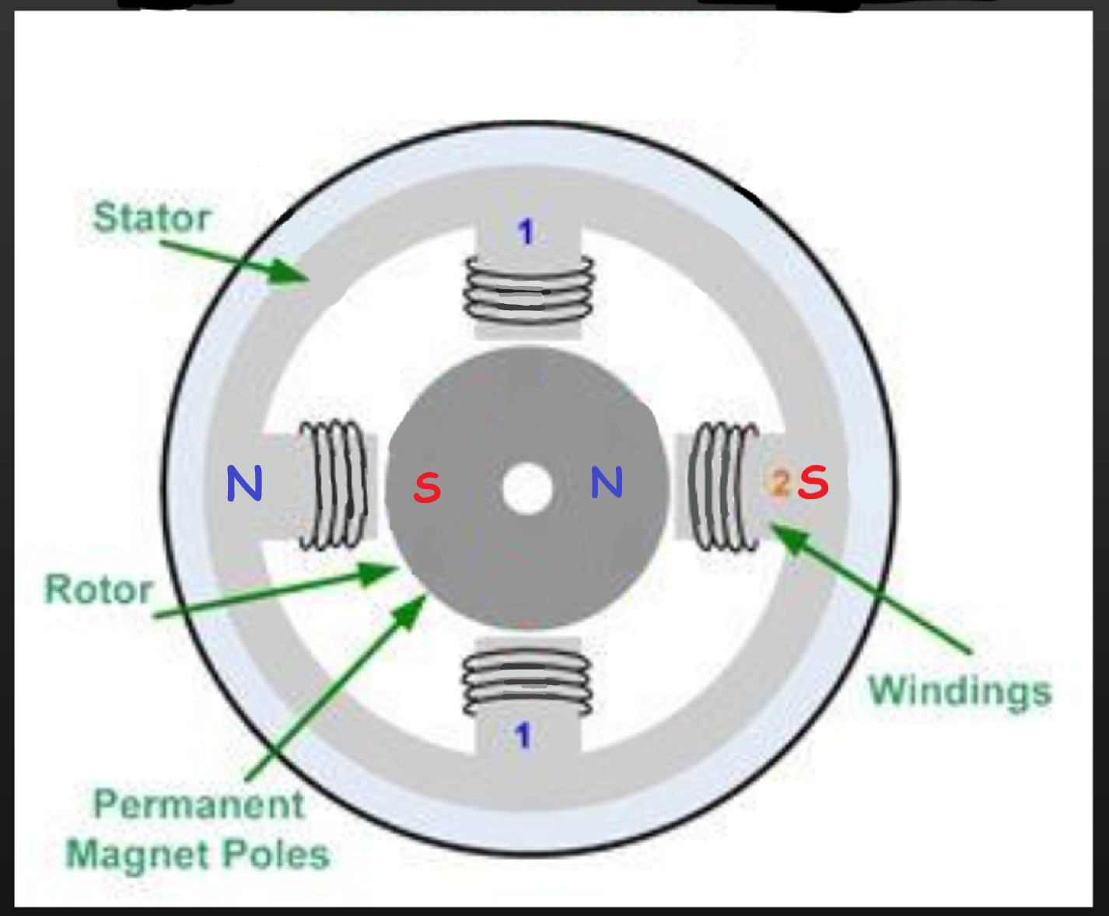

Transition – De-energizing Phase 2, Phase 1 – South to North Energized

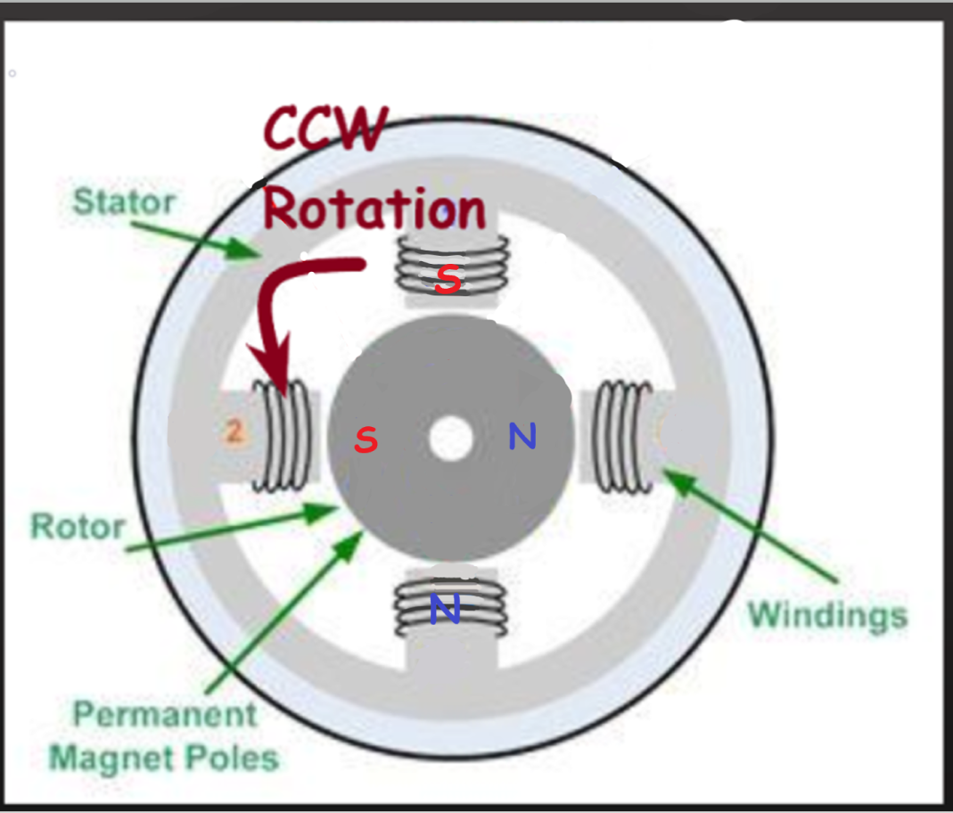

Equilibrium position 5(1) – Phase 1 – South to North Energized, Phase 2 Off



1. Your stepper motor is rated at 2 amps supply current per phase. There are two phases in the stepper motor. During full stepping what is the total motor current drawn:

Answer: **2.828A**

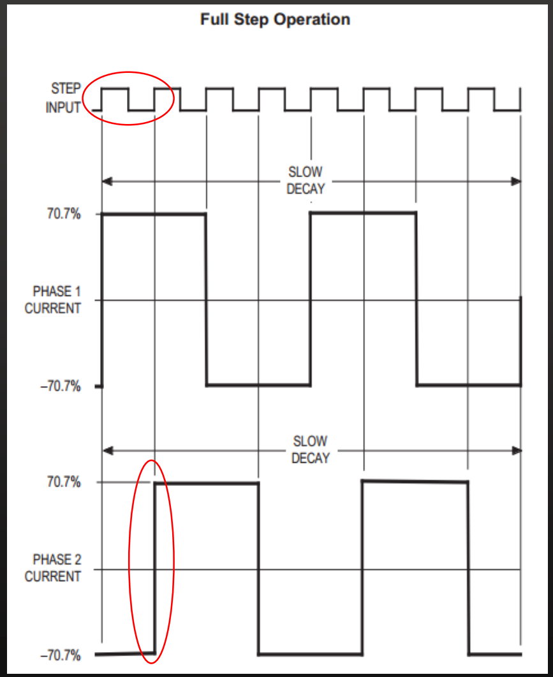

From the above graph, we know that each phase draws 0.707 times the max current during on time (vector sum is 1.414) – and therefore, for full step operation the current drawn =

0.707 * no. of phases * current per phase = 0.707 * 2 * 2 = 2.828A

1. Your stepper motor is rated at 2 amps supply current per phase. There are two phases in the stepper motor. During half stepping what is the total motor current drawn?

Answer: **2.414A**

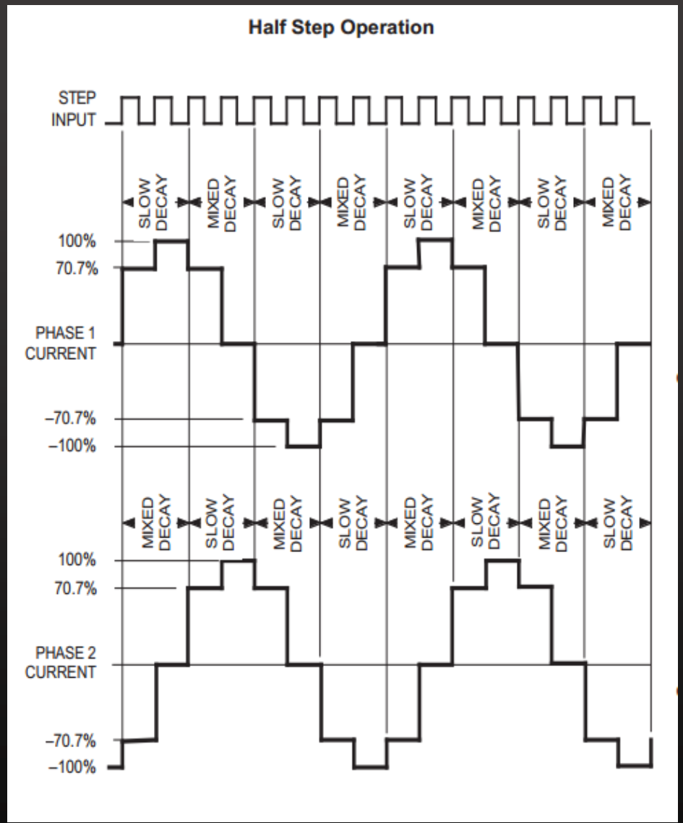

From the above diagram, the average current of one phase during one cycle is:

(2 * (0 + 0.707 + 1 + 0.707)) / 8 = 2.414 / 4 = 0.6035. Using this, the final current:

0.6035 * number of phases * current per phase = 0.6035 * 2 * 2 = 2.414A

1. Just like AC motors, stepper motors have a variety of terminology for their torque output. Answer the following questions about their torque output?

References: [**[2]**](https://www.motioncontroltips.com/faq-whats-the-difference-between-detent-torque-and-holding-torque/)[**[3]**](https://www.orientalmotor.com/stepper-motors/technology/speed-torque-curves-for-stepper-motors.html)[**[4]**](https://www.motioncontrolonline.org/blog-article.cfm/Microstepping-Tutorial-A-Brief-Overview/47)[**[5]**](https://www.motioncontrolonline.org/blog-article.cfm/Microstepping-Tutorial-A-Brief-Overview/47)[**[6]**](https://www.micromo.com/technical-library/stepper-motor-tutorials/microstepping-myths-and-realities)[**[7]**](https://www.machinedesign.com/basics-design/microstepping)

E.1 What is the detent torque and why is it useful when stopping the stepper motor?

Answer: **Detent torque is the amount of torque the motor produces when the windings are not energized**. The effect of detent torque can be felt when moving the motor shaft by hand, in the form of torque pulsations or cogging. Detent torque can be beneficial when stopping the motor. **The momentum of the moving rotor is countered by the detent torque and the friction in the rotating components. Therefore, a higher detent torque will help the motor to stop more quickly.**

E.2 Which type of stepper motor does not exhibit detent torque?

Answer: **Variable reluctance stepper motor doesn’t exhibit detent torque.** This is because this type of stepper motor doesn’t have permanent magnets and therefore no detent torque (as no magnetic force without electric current).

E.3 Quantitatively, how does detent torque relate to holding torque in a stepper motor that exhibits detent torque?

Answer: **The detent torque typically ranges from 5% to 20% of the holding torque.**

E.4 What is pull-in torque curve, and why is it important?

Answer: There are two types of pull-in torque curve: no load and inertial load. **This curve represents the maximum torque and speed combination that a stepper motor with an inertial load (or without load) can supply to a load and start or stop without any acceleration or deceleration.** It is important since it can be interpreted as the starting torque, and in order to operate above the pull-in torque curve, the motor must be accelerated into or decelerated out of the slew range. Thus, the **stepper motor won’t be able to start until the required starting torque is less than pull-in torque.**

E.4 What is the major advantage and disadvantage of using microstepping vs. full stepping in driving a stepper motor?

Answer:

Advantages of Microstepping:

* The biggest advantage of microstepping is smooth operation and the elimination of resonance over its entire speed range
* Smooth operation permits full torque utilization and freedom from rattling and mechanical wear
* Generally easy to install and use because they have no tuning or setup requirements
* They are stable and free from drift when stopped

Disadvantages of Microstepping:

* Increment in the number of microsteps per full step results in the incremental torque per microstep dropping off drastically
* Resolution increases but accuracy goes down

1. A stepper motor has the following attributes:



What is the speed of the motor output shaft as measured in RPM?

Answer: **30 RPM**

As per the given information, it takes 50 pulses to rotate 90°. Also, assuming that it is operating in full step mode – one step takes one pulse. Therefore, step size is 90/50 = 1.8°. As the pulse speed is 100Hz, there are 100 pulses or steps being rotated in 1 second. Thus, 100 * 1.8 = 180° rotation taking place per second, resulting in one full revolution at every 2 seconds. Therefore, it is rotating at 30 RPM.

1. The angle between rotor teeth of permanent magnet stepper motor is 3.6° and there are five stator phases in this motor. What is the step angle in this motor?

Answer: **0.72°**

As per the given information – the angle is 3.6° between rotor teeth – making it equivalent to pitch. Finding the number of teeth of rotor using this - 360° / 3.6° = 100. The step angle is given as per the following:

360° / (number of phases * number of teeth in rotor) = 360° / 500 = 0.72° [**[8]**](https://circuitglobe.com/variable-reluctance-stepper-motor.html) 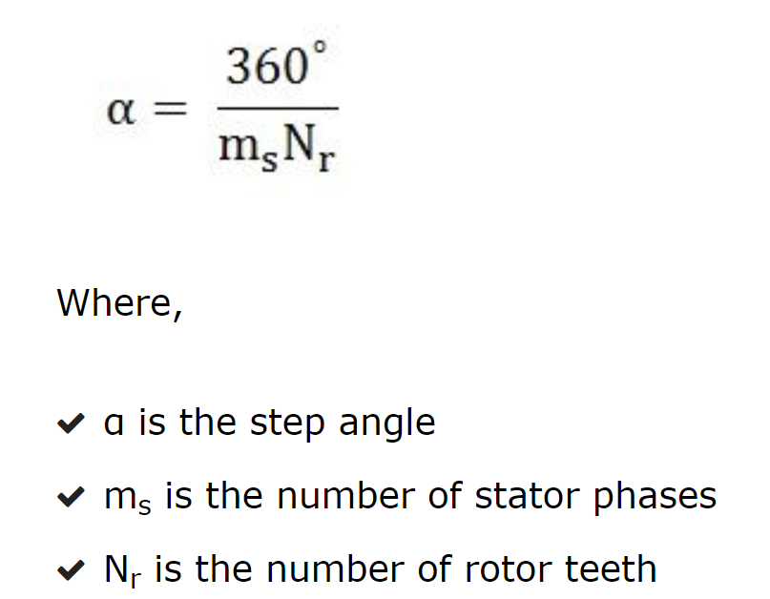

1. What is the maximum starting frequency of stepper motor? What will the starting frequency of the stepper motor under load under this situation?



Answer: Maximum Starting Frequency is the **maximum pulse speed at which the motor can start or stop instantly (without an acceleration/deceleration time) when the stepper motor’s friction load and inertial load are 0.**

For the given motor, starting frequency can be found using following equation [**[9]**](https://www.orientalmotor.com/stepper-motors/technology/stepper-motor-overview.html) : 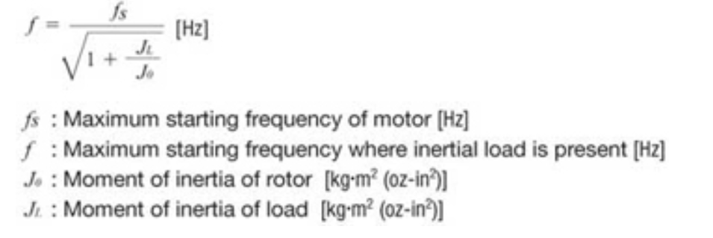

**43.49 Hz**

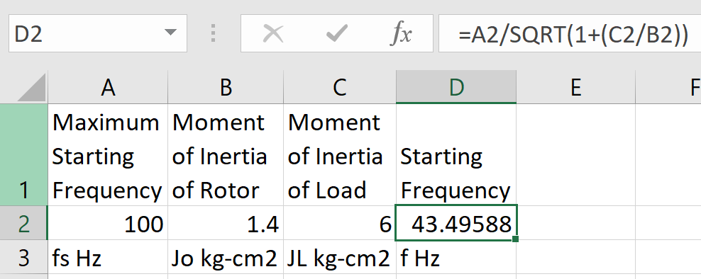

1. Describe how a variable reluctance stepper motor. What is the big limitation of this type of stepper motor?

Answer: The principle of Variable Reluctance Stepper Motor is based on the property of the flux lines which capture the low reluctance path. The stator and the rotor of the motor are aligned in such a way that the magnetic reluctance is minimum [**[10]**](https://circuitglobe.com/variable-reluctance-stepper-motor.html) . The basic construction is shown below:

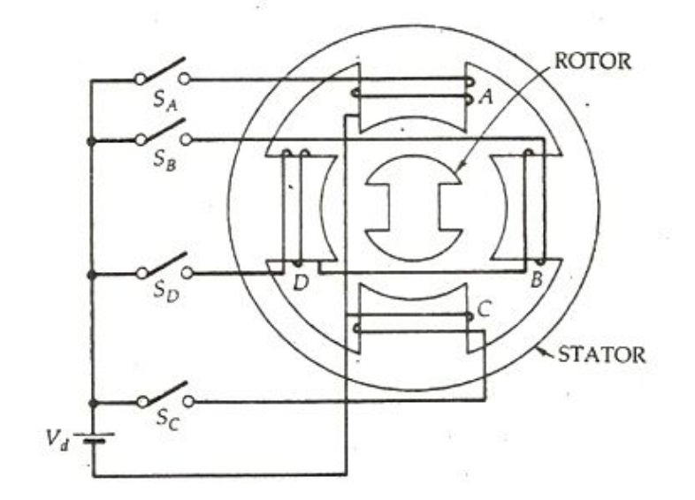

Working:

* The four phases A, B, C and D are connected to the DC source with the help of a semiconductor, switches SA, SB, SC and SD respectively as shown in the above figure.
* The phase windings of the stator are energized in the sequence A, B, C, D, A. The rotor aligns itself with the axis of phase A as the winding A is energized. The rotor is stable in this position and cannot move until phase A is de-energized.
* Now, the phase B is excited and phase A is disconnected. The rotor moves 90 degrees in the clockwise direction to align with the resultant air gap field which lies along the axis of phase B.
* Similarly, the phase C is energized, and the phase B is disconnected, and the rotor moves again in 90 degrees to align itself with the axis of the phase
* Thus, as the Phases are excited in the order as A, B, C, D, A, the rotor moves 90 degrees at each transition step in the clockwise direction. The rotor completes one revolution in 4 steps.
* The direction of the rotation depends on the sequence of switching the phase and does not depend on the direction of the current flowing through the phase. Thus, the direction can be reversed by changing the phase sequence like A, D, C, B, A.
* The step angle can be reduced from 90 degrees to 45 degrees in a clockwise direction by exciting the phase in the sequence A, A+B, B, B+C, C, C+ D, D, D+A, A.
* Here, (A+B) means that the phase windings A and B both are energized together. The resultant field is the midway of the two poles. i.e. it makes an angle of 45 degrees with the axis of the pole in the clockwise direction. This is known as half-stepping.

Disadvantages:

* The biggest down side of this type of stepper motor is that it is having Low Torque [**[11]**](https://nptel.ac.in/courses/112103174/module4/lec2/1.html) .
* Speed is lower compared to DC motors.
* Resonances can occur if not properly controlled.
* Not easy to operate at extremely high speeds [**[12]**](http://www.academia.edu/4777256/Stepper_Motor_Advantages_and_Disadvantages) .

1. Explain which of the 4-wire, 5-wire, and 6-wire stepper motors can be driven by unipolar, bipolar, or both types of stepper motor drives?

Answer:

**4-wire -> Bipolar -> Need bipolar driver**

**5-wire -> Unipolar -> Need unipolar driver**

**6-wire -> Unipolar or Bipolar -> Both type of driver [[13]](https://learn.adafruit.com/all-about-stepper-motors/types-of-steppers)**